ALB Ingress SSL:-
The tutor had used Rout 53. Since it costs more money I’ll be using External DNS.
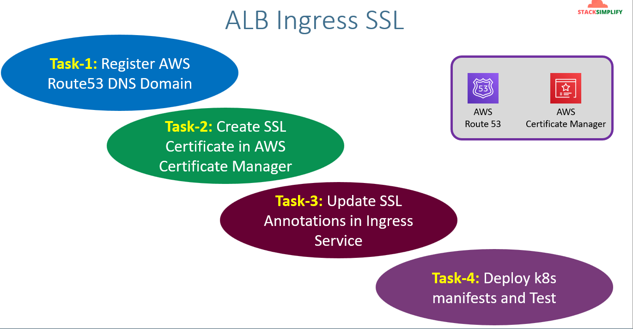
The network design will look like below
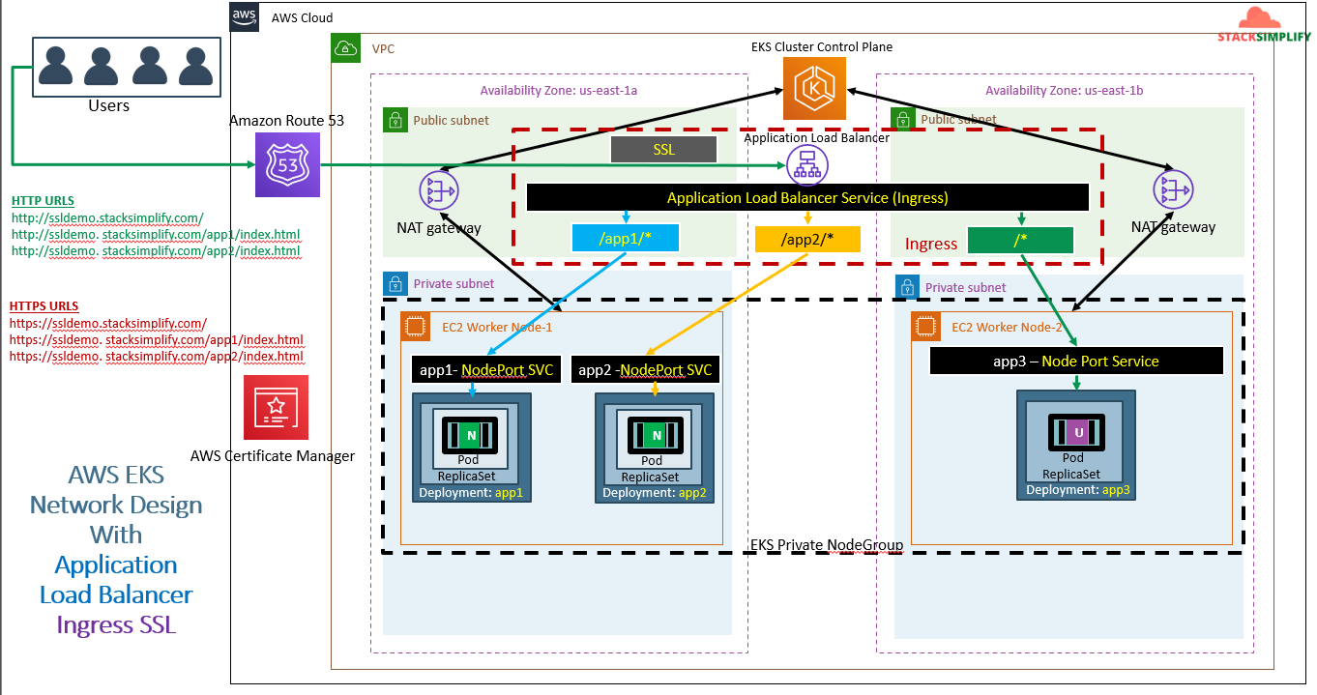
We are going to place external DNS in the place of Route 53. We are going to create the SSL certificates in AWS certificate manager and we are going to attach it to ALB through ingress service annotations. We are going to register the ALB DNS name with the custom DNS name.
We are going to access both HTTP and HTTPS services and we will see ssl redirects that HTTP to HTTPS.
Creation of SSL certificates:
Search certificate manager -> click on ‘request’ -> Request a public certificate -> click ‘Next’
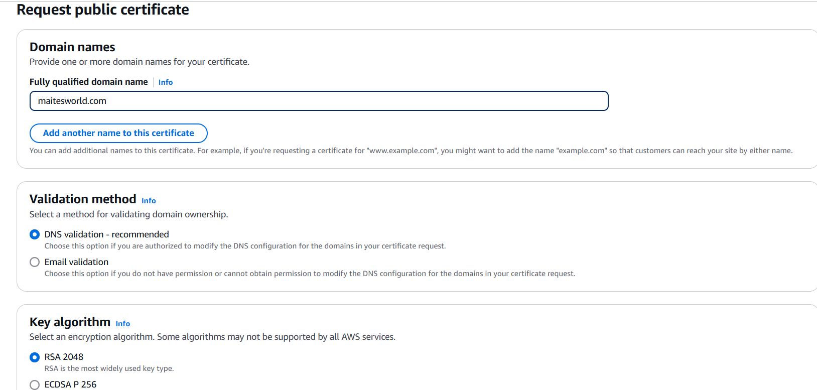
Click on ‘request’.
After that the certificates will list under certificates section. Click on ‘certificate id’. While creating certs I have added maitesworl.com and *.maitesworld.com as Domain names in above SS.
Now, after clicking on ‘certification id’, you can see my domain names like below.
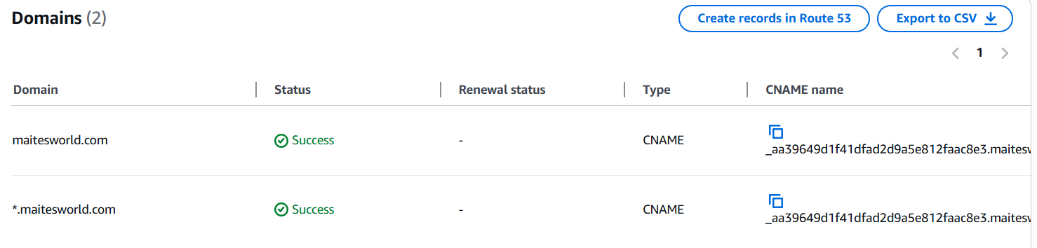
Here we need to collect the CNAME name and CNAME value. If it’s different for domain and sub domain collect both.
Now, go to Godaddy -> DNS -> DNS records and click on ‘Add new record’.
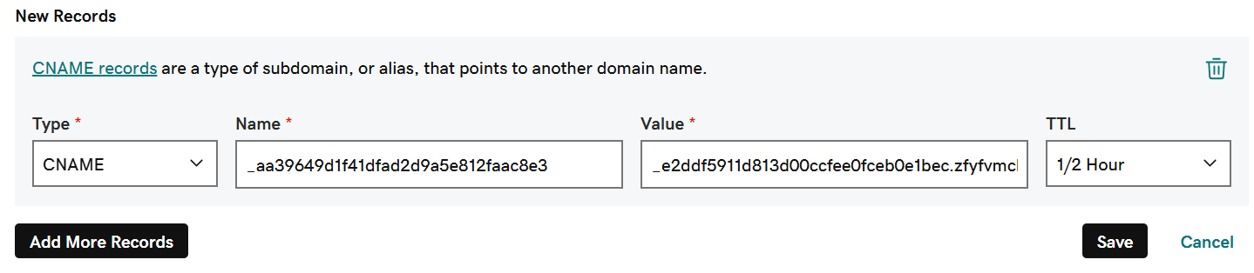
Add our CNAME name and CNAME value like above.
Note:- For CNAME it will look like this ‘_aa39649d1f41dfad2d9a5e812faac8e3.maitesworld.com.’ while adding in CNAME record in Godaddy we need add like ‘_aa39649d1f41dfad2d9a5e812faac8e3’. Refer above SS.
After adding wait for few minutes now go and verify in certificates section in AWS secret manager you can see the status as ‘issued’ instead of ‘pending validation’.
If we use Route 53 DNS we need to click on ‘create records in Route 53’ this will automatically add the records to Route 53 records. You can cross check this in Hosted zones section.
External DNS:- The above mentioned process is External DNS process.
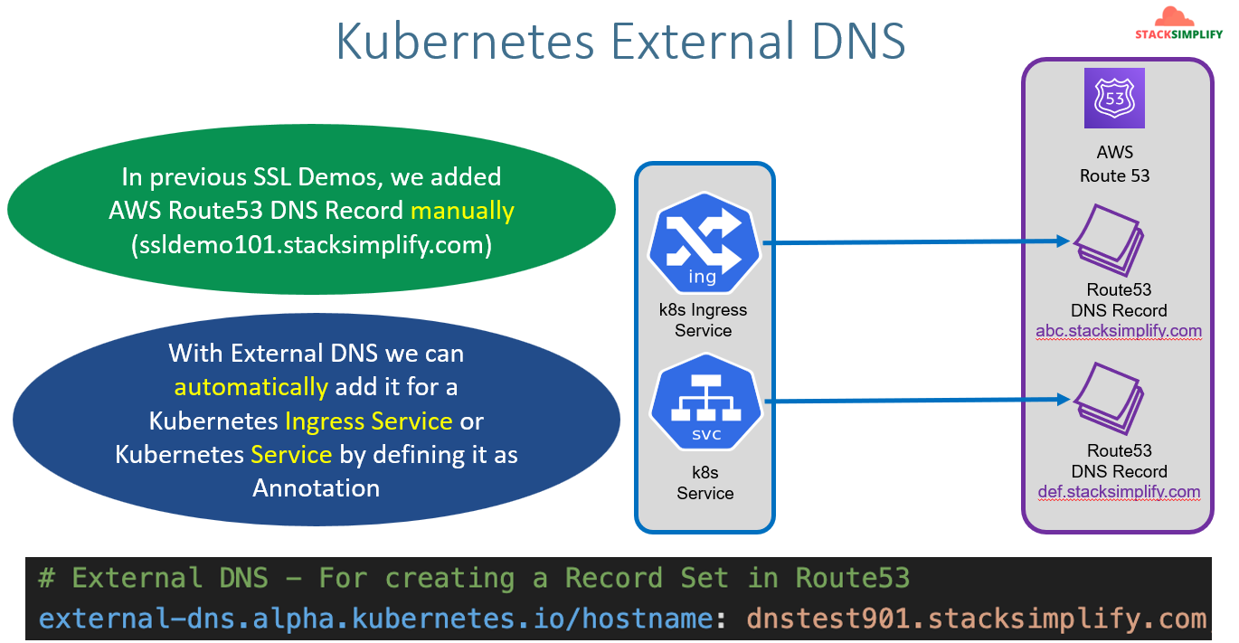
In Ingress manifest we will define the external DNS records as annotations those will be added directly to DNS records.
Components involved in Extrenal DNS: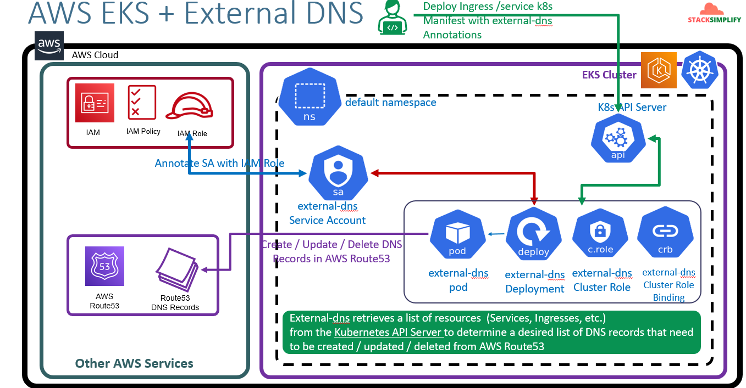
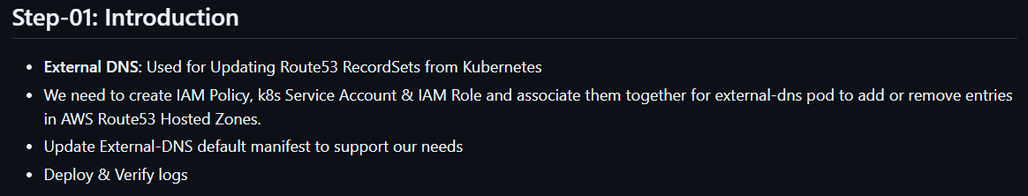
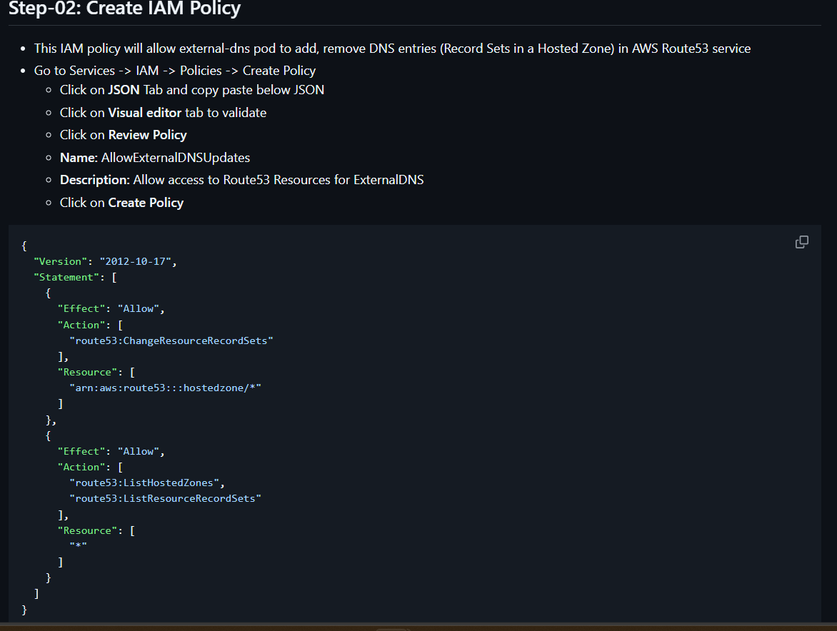
After creating the policy we need to create service account by using above ploicy’s ARN. It will create Service Account along with role for that policy.
Policy ARN : arn:aws:iam::273354622518:policy/AllowExternalDNSUpdates
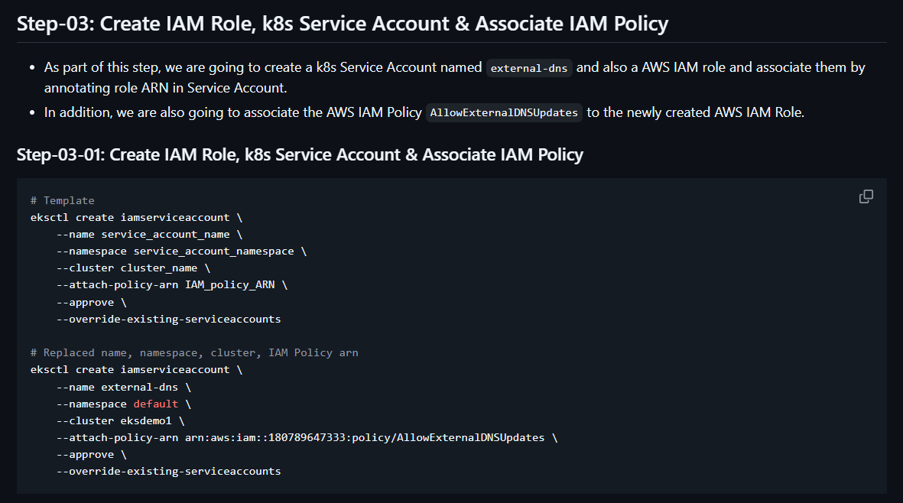
The output is
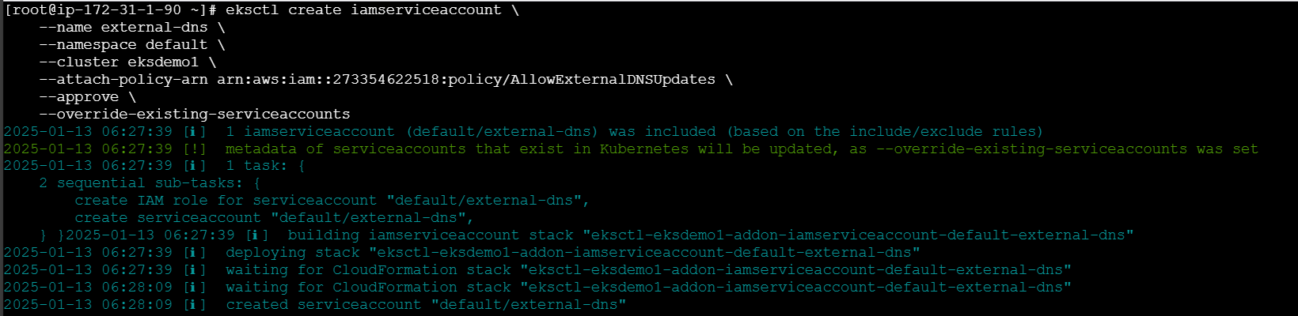
The output of get and describe is
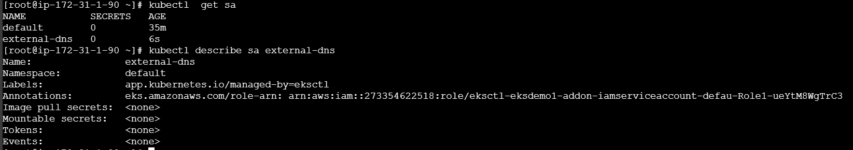
In describe command you can see role got created automatically with the name ‘eksctl-eksdemo1-addon-iamserviceaccount-defau-Role1-ueYtM8WgTrC3’.
Now we are going to write a manifest for SA to annotate the IAM role and we are going to write role, rolebinding and deployment with which it will create to external DNS with external DNS pods. You can get the script in aws-eks-kubernetes-masterclass/08-NEW-ELB-Application-LoadBalancers/08-06-Deploy-ExternalDNS-on-EKS/kube-manifests/01-Deploy-ExternalDNS.yml at master · stacksimplify/aws-eks-kubernetes-masterclass .
You can get the more info in official doc: external-dns/docs/tutorials/aws.md at master · kubernetes-sigs/external-dns .
After making below changes run apply commnd.
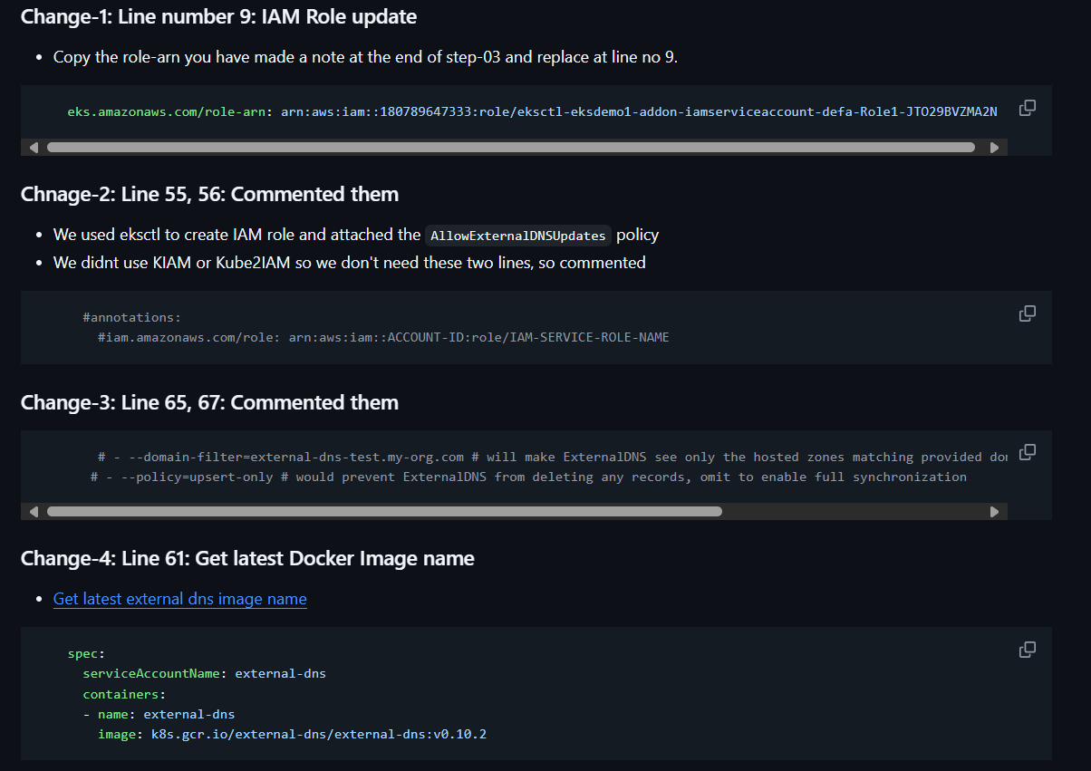
Another way to get pods.
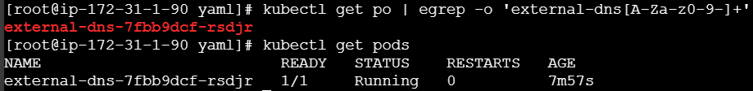
This will can be used to get unknown pods. Eg: If you want to get logs of unknown pods you can run ‘kubectl logs -f $(kubectl get po | egrep -o 'external-dns[A-Za-z0-9-]+')’.
If you see the script we have already created the below part. But, for simple reference I have added it. You can remove it if you want. 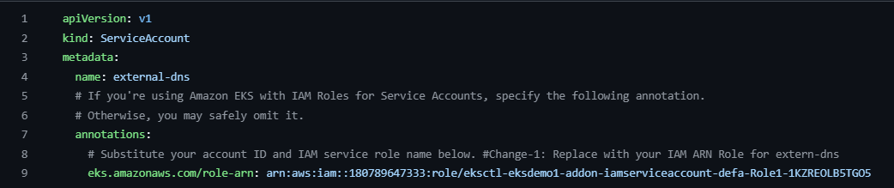
Adding External DNS annotation:-
Now, we are going to define External DNS annotation with which it will create automatically the DNS records.
Network diagram will look like below.
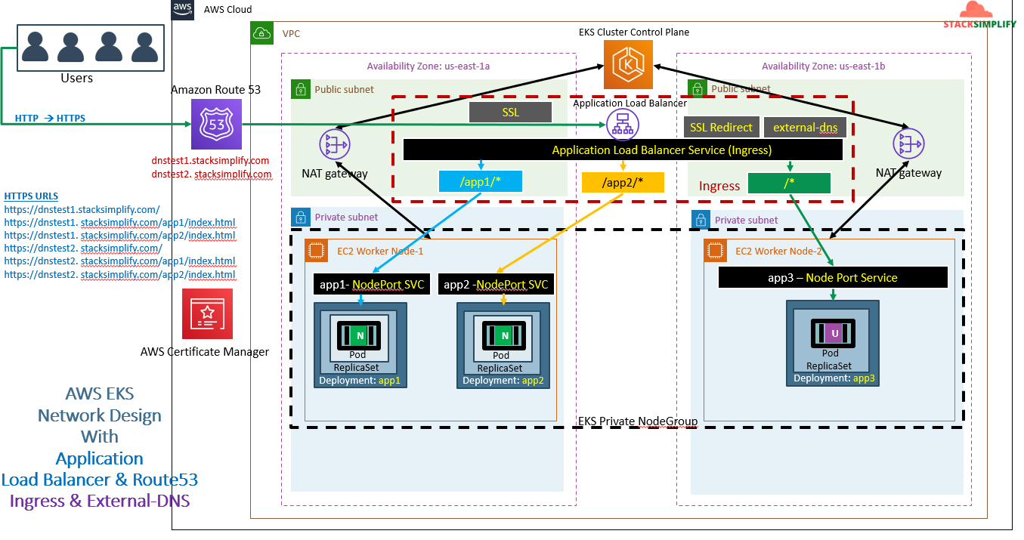
Now we are going to run the 3 applications with deployments along with ingress service. We copy the scripts from previous session. We will add below ‘ssl settings’. Before that, go to Rout53 hosted zones create a public hosted zone with your DNS that is maitesworld.com
If you see we have defined port number 443 for https and 80 for http. So when you try with http and https it will work.
If you see certificate-arn from above SS. We need to add our SSL certificate ARN which we have generated in AWS certificate manager.
Since http is not a secured way we need to define the SSL redirects. For that we will mention above annotation. So when you try to search with http it will automatically take you to https.
If you see the above annotation. We can access the services with different sub domains. Eg: App1 with one sub domain DNS and APP2 with another sub domain. To define multiple sub domains we need to use ‘,’ as separator.
The update annotations will be
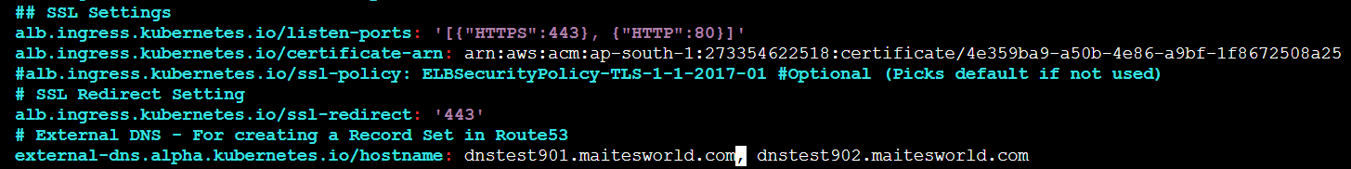
After updating the above changes to ingress manifest file run apply command.
It will create Ingress service. Before running the Ingress service be sure to running external DNS and load balancer controller service accounts along with load balancer controller pods and external DNS pods are running.
You can see all the pods below.
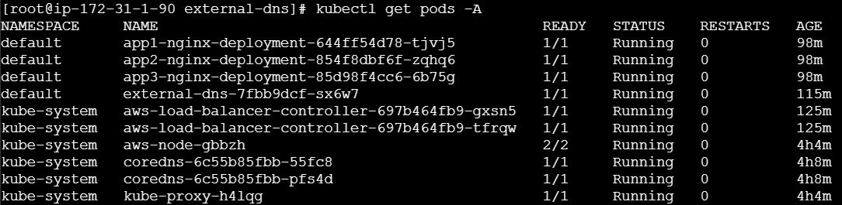
Once everything is up check ‘kubectl describe ingress <ingress-service name>’. No errors should be there.
Always check for external dns pod logs.It should show create and successfully updated.
Now go to Rout53 hosted zone you can see the updated records.
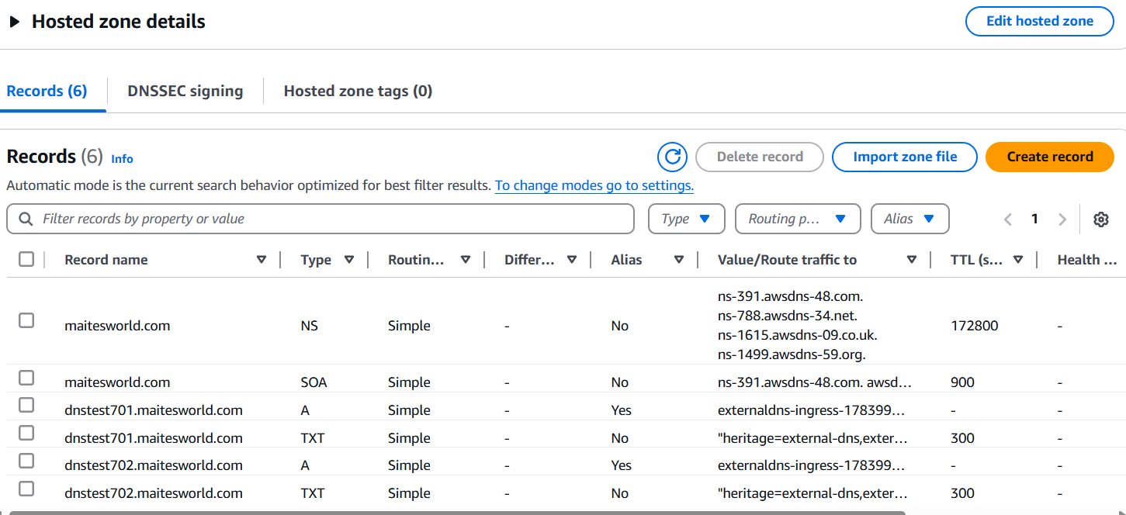
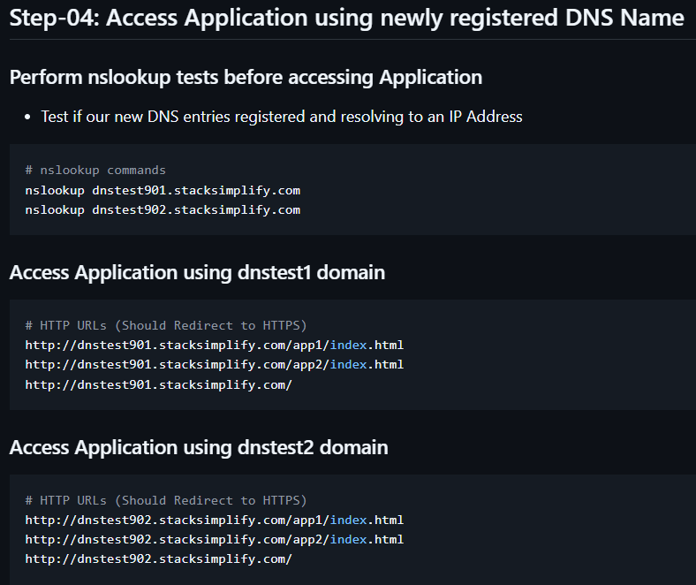
If nslookup is not working, we need to add nameserver details in Godaddy under DNS.
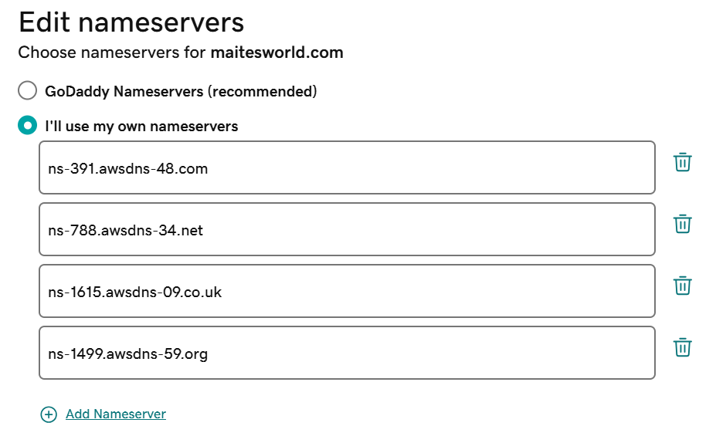
Still not working it may stale cache issue while checking nslookup add 8.8.8.8 or 1.1.1.1 at end of nslokup command.
IF still not working go to Hosted zones in Route53 > Go to created DNS record select dual stack one and save it. Wait for few minutes it will work.
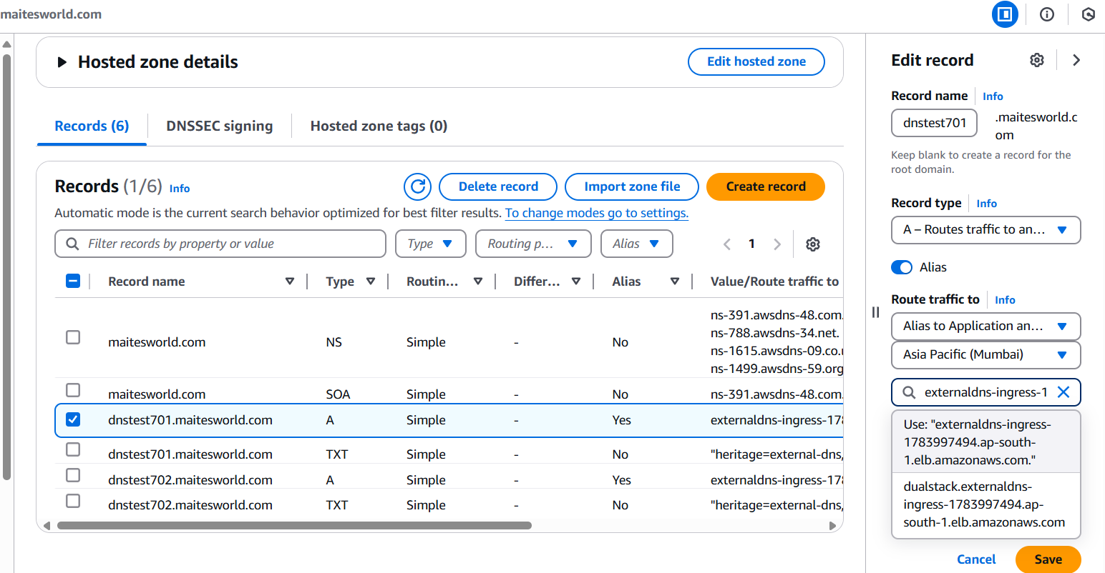
Note:- If you observe you the url you can see it will be accessing https url.
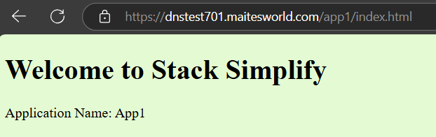
Kubernetes service demo with External DNS:-
Here, we are going to use service to create LB with External DNS.
Network:
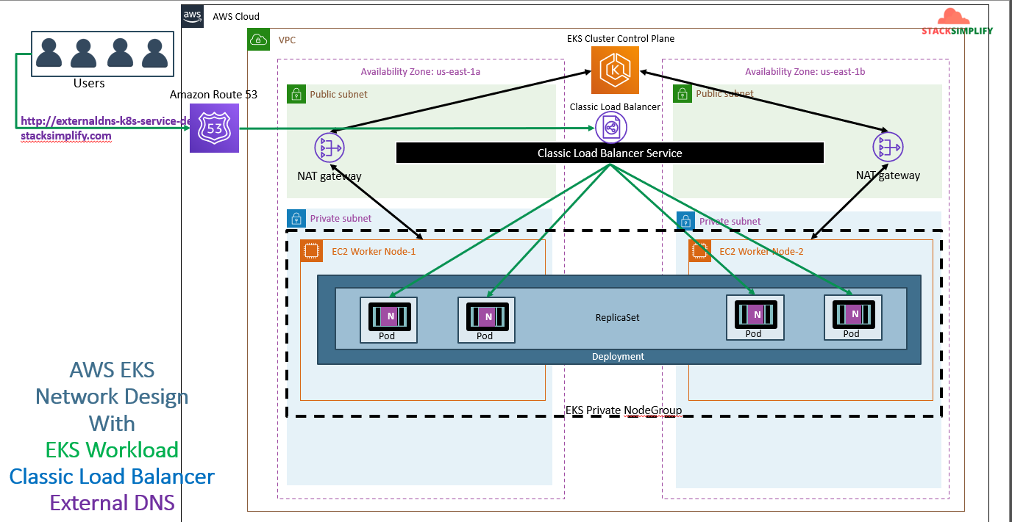
The service script will look like below SS. We are going to use the annotation ‘external-dns.alpha.kubernetes.io/hostname: externaldns-k8s-service-demo101.stacksimplify.com’.
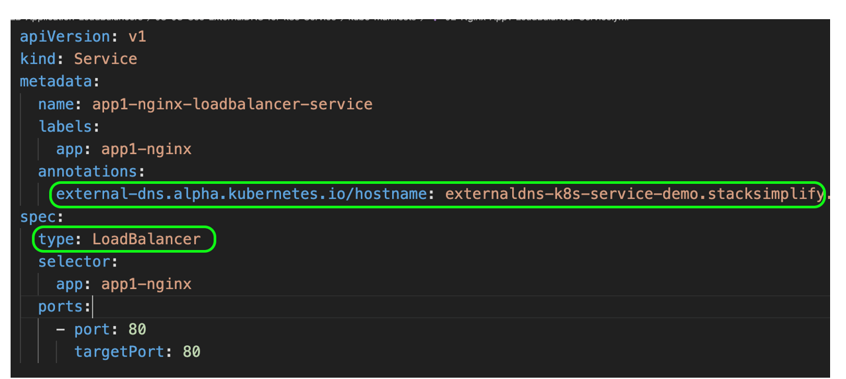
Observe the external DNS pods logs.
